HR Program and Project Management Methodologies

**Are you well prepared to support or even lead programs and projects within your department and more broadly within your company? When you look at a list of key HR competencies, one thing that often is lacking is a good set of project management skills. While it’s easy to try and segment the human resources profession away from the project manager role, I see it as a core part of what you have to do. Today we’ll go over some of the key aspects of HR project management, what it is, where it fits into your career, and how to use it.**

***The objectives of the presentation will be:***

***\* Create a shared understanding of the core roles and responsibilities of an HR organization***

***\* Understand what Program/Project Management involves***

***\* Understand how to best leverage Program/Project Management to achieve HR goals***

*About our Presenter:*

**Aaron Hamlin, Operational Excellence Project Manager**

Aaron is a passionate and pragmatic practitioner of Lean Six Sigma, Aaron Hamlin's career has spanned a number of industries including financial services, HR/Benefits outsourcing, bio-manufacturing, life science, security, insurance and precision manufacturing. Collaboration, innovation and a proven ability to deliver results have been hallmarks of his career. Aaron graduated with a B.A. In Social Studies Education and a B.A. in World History from Notre Dame College in Manchester, NH where he also played intercollegiate Men's Basketball. A native of Western Maine, Aaron settled on the North Shore of Massachusetts over 20 years ago. In his free time, Aaron enjoys coaching and volunteering for his son's activities, running trails on the North Shore, reading and fly fishing back home in Maine as often as he can.

Registration opens February 21st at [www.mahra.org](http://www.mahra.org)

***Program Sponsor***



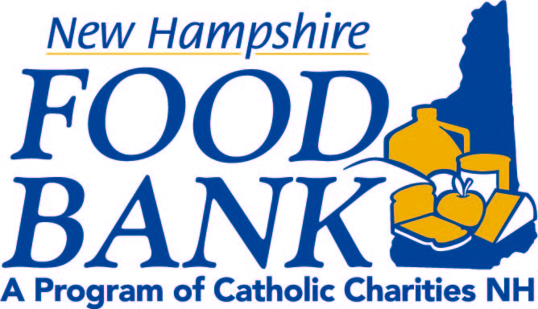

***We will be hosting a Food Drive for the NH Food Bank.***

***Most needed items include:***

*Canned Tuna, Canned Chicken, Peanut Butter & Jelly, Mc n Cheese, Canned Soup/Stew/Chili, Canned/Dried Beans, Canned Nuts, Rice Mixes, Pasta, Noodle Mixes.*