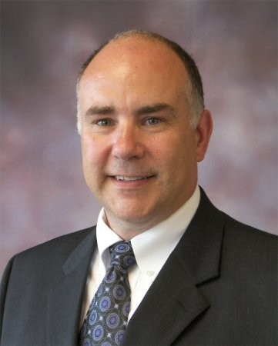
Marc Theophelakes- LSS Master Black Belt, CPP Master
Business Performance Consultant

As a senior operations leader with proven success establishing strategic visions with operational excellence, Marc provides consulting and training for clients with focus on leadership, process improvement, and lean principles. Dynamic leader with a history of assembling, developing, and leading high-performance teams. Strong Continuous Improvement practitioner, removing waste from the operations and establishing standards.

Marc has 36 years of leadership experience in food retailing and supply chain. He has held senior leadership roles including, Global Chief Supply Chain Officer, VP of Retail Operations and many Director roles. He is a certified Lean/Six Sigma Master Blackbelt and a Certified Process Professional Master. He has worked with many reputable companies of all sizes such as Meijer, Shaw’s, Farm Fresh, Supervalu, and UNFI.
Marc enjoys competitive sports, hiking, boating and anything that will get him outdoors with his family.

